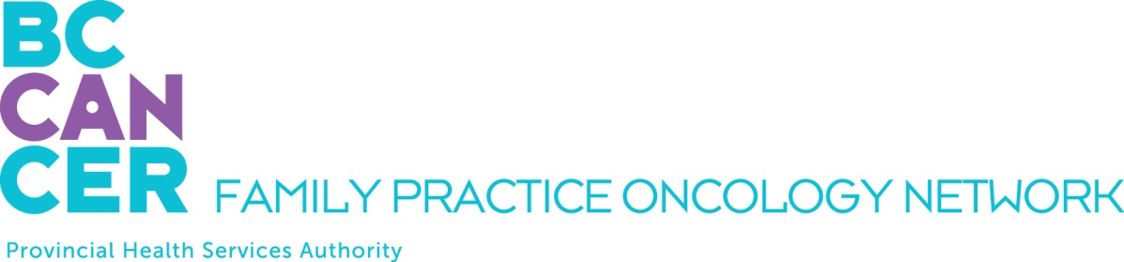

CPO Education Program Application

4 Week Virtual Introductory Module Only:

*This form is for applicants who wish to attend only the 2 week Introductory Module of the GPO Education Program.

APPLICANT DETAILS

NAME OF APPLICANT:

First Name, Middle Initial, Last Name

ADDRESS
Street # and name, City, Province, Postal Code

TELEPHONE NUMBERS:
Office:
Mobile:

EMAIL ADDRESS:

INTRODUCTORY MODULE YOU PLAN TO TAKE:

Fall 2023 Virtual Delivery: morning lectures, September 11 – 22, and October 3 – 17

Spring 2024 Virtual Delivery: morning lectures only, February 5 – 16, and February 26 – March 8

BRIEFLY STATE YOUR REASONS FOR WANTING TO TAKE THE PROGRAM:

CAREER GOAL

POST GPO EDUCATION PROGRAM CAREER GOAL:
Palliative Care Physician
Other – please specify

CURRENT PRACTITIONER INFORMATION

Name of your licensing body:

Are you a member in good standing? Yes No

REQUIRED ATTACHMENTS

PLEASE INCLUDE THE FOLLOWING WITH YOUR APPLICATION:

Letter of support from your program director or equivalent (as appropriate)

If you are not providing the above, please include a personal statement outlining your rationale for wanting to take the program

Current Curriculum Vitae

SUBMIT YOUR APPLICATION BY EMAIL

Ensure all documentation is available prior to submitting your application. Please email your complete application – including all attachments – as one PDF document (with this application form at the front) to:

Dilraj Mahil, Project Coordinator
Family Practice Oncology Network
BC Cancer
600 W. 10th Ave.
Vancouver, BC V5Z 4E6
dilraj.mahil@bccancer.bc.ca

Kindly submit your application at your earliest convenience. We thank you for your interest and will advise you promptly as to your acceptance into the program.

