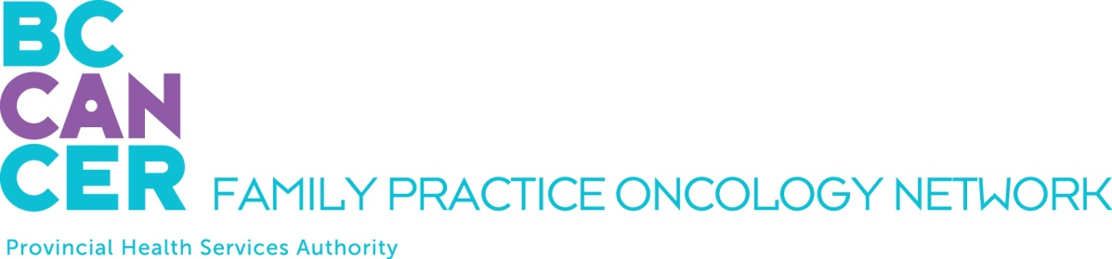

CPO Education Program Application
For Nurse Practitioners - 4 Week Virtual Program only:

Please ensure you have reviewed the Program mandate on the Network Website.

APPLICANT DETAILS

NAME OF APPLICANT:

First Name, Middle Initial, Last Name

ADDRESS
Street # and name, City, Province, Postal Code

TELEPHONE NUMBERS: EMAIL ADDRESS:
Office:
Mobile:

INTRODUCTORY MODULE YOU PLAN TO TAKE:

Spring 2025 Virtual Delivery: morning lectures only, February 3 – 14, and February 24 – March 7

Fall 2025 Virtual Delivery: morning lectures only, September 8 – 19, and September 29 – October 10

REQUIRED ATTACHMENTS

PLEASE INCLUDE THE FOLLOWING WITH YOUR APPLICATION:

A letter of support from your program director

SUBMIT YOUR APPLICATION BY EMAIL

Please email this application as a PDF document to:

Clarice Liao, Project Coordinator
Family Practice Oncology Network
BC Cancer
600 W. 10th Ave.
Vancouver, BC V5Z 4E6
clarice.liao@bccancer.bc.ca

Kindly submit your application at your earliest convenience. We thank you for your interest and will advise you promptly as to your acceptance into the program.

