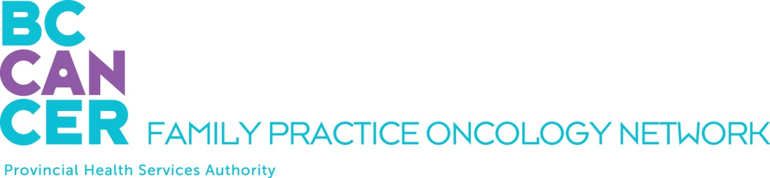

GPO Education Program Application
For Nurse Practitioners - 2 Week Program only:

Please ensure you have reviewed the Program mandate on the Network Website.

APPLICANT DETAILS

NAME OF APPLICANT:

Last Name, First Name, Middle Initial

ADDRESS
Street # and name, City, Province, Postal Code

TELEPHONE NUMBERS: EMAIL ADDRESS:
Home:
Office:
Mobile:

INTRODUCTORY MODULE YOU PLAN TO TAKE:

September 10 – 21, 2018

February 18 – March 1, 2019

REQUIRED ATTACHMENTS

PLEASE INCLUDE THE FOLLOWING WITH YOUR APPLICATION:

A letter of support from your program director

SUBMIT YOUR APPLICATION BY EMAIL

Please email this application as a PDF document to:

Jennifer Wolfe
Program Manager
Family Practice Oncology Network
BC Cancer
600 W. 10th Ave.
Vancouver, BC V5Z 4E6
T: 604 219 9579
jennifer.wolfe@bccancer.bc.ca

Kindly submit your application at your earliest convenience. We thank you for your interest and will advise you promptly as to your acceptance into the program.

